Physics 236 - Engineering Physics II

Department of Physical Science and Engineering

Wilbur Wright College

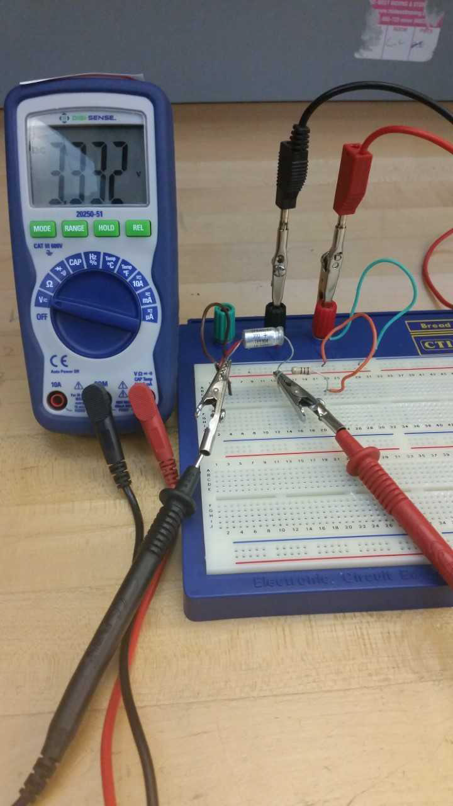

Study of RC Circuits using a DC Power Supply

Objectives

The purpose of this laboratory is to reproduce experimentally the charging and discharging curves for the capacitor and measure the time constant τ = RC

Materials

* DC power supply, (4 V)
* DMM
* Bread-Board Circuit,
* 1 MΩ resistor – **brown black green gold**
* 100 μF polarized capacitor (silver color) 104.7 uF
* wire leads and alligator connectors.

Theory

Charging process

In a circuit where a resistor and capacitor are connected to a DC power supply like the figure below

When switch is at *a*, the charging process starts. The graphs shown below correspond to charging a capacitor in series with a resistor connected to a DC battery. At time t = 0 when the switch is close the capacitor start charging gradually until the charge stored in the capacitor is the maximum. Notice the meaning of the time constant .

is the time when the value of the charge in the capacitor is 63% of the maximum charge , where is the emf of the DC power supply and C is the capacitance of the capacitor. Also notice that the current across the capacitor decrease to zero very fast. At a time of about 4τ the capacitor is fully charged and the current across the capacitor is practically zero.

Graph of charge *q* as function of time in the charging process - RC circuit (*) taken from Serway

Graph of current as function of time in an RC circuit (*) taken from Serway

In the charging process the charge is described by

You can manipulate this expression dividing both sides by the capacitance to have an expression for the voltage across the capacitor as a function of t, like

Now using we can have an expression for the current

Where the maximum current has a value

Discharging process

When the switch in the circuit is open, leaving the DC power supply out of the loop, the capacitor starts discharging, the behavior of the charge as a function of time looks like the graph below

Graph of charge *q* as function of time in the discharging process - RC circuit (*) taken from Serway

The initial charge in the capacitor is given by , also notice that for the discharge curve the charge in the capacitor is given by

And then we can also have an expression for the voltage across the capacitor . Thus, when t = RC the voltage across the capacitor is 36% of the total Voltage of the DC power supply.

Part I. Calculate the value of the time constant τ = RC

The nominal value of the capacitor provided is 100 μF**.** Measure the capacitance of the capacitor using the DMM. Select the function CAP in the blue DMM or capacitors option in the yellow fluke multi-meter. Connect the probes across the capacitor, be sure you make a good contact and wait several seconds until you obtain a stable reading.

Capacitance value = 104.7 μF

Measure the value of the resistor using the DMM connecting the probes of the multi-meter across the resistor and wait until you have a stable reading

Resistor value R = .987 MΩ

Calculate the time constant τ using the numerical values found with the multi -meter. For the time constant τ = RC to be in seconds, the capacitance C must be in Faraday and the resistance R in ohms. Also calculate the nominal value for τ using the stated values for R = 1 MΩ, and C = 100 μF. Using the expression for percent error

Calculate the % error and record all these values in the following table

|  |  |  |
| --- | --- | --- |
| **[s]** | **[s]** | % Error |
| 103.3389 | 100 | 3.3389% |

Part II. Charging the capacitor

Assembly the series-RC circuit shown below. When t = 0 seconds, close the switch at position *a* and connect the probes of the multi-meter across the capacitor be sure to make good contact and measure the voltage every 5 or 10 seconds. Record your values in the table. **Note that the capacitor is polarized**. The negative lead of the capacitor must be connected to the negative terminal of the battery.

Include a picture of your set up in the report

|  |  |
| --- | --- |
| Time [s] | Voltage across capacitor Vc[V] |
|  |  |
|  |  |
|  |  |
|  |  |
|  |  |
|  |  |
|  |  |
|  |  |
|  |  |
|  |  |
|  |  |
|  |  |
| 8:20 | 3.548 |
| 8:30 | 5.556 |
| 9:00 | 3.575 |
| 9:30 | 3.589 |
| 10:30 | 3.612 |
| 12:00 | 3.634 |
| 13:00 | 3.648 |
|  |  |

Make a graph of voltage across the capacitors as a function of time. Do not join the points with a curve. Locate in the vertical scale the point 63% . Then find the time constant .

HERE (and just for the charging process) linearize the expression for the voltage

Yes! there is natural log included and then make a graph as function of time. Make the best fit line, ask excel (or any method you decide) to give you the equation. Interpret the equation, what does the slope mean? Can you compare the slope with something you know already?

Include the table of data for the graph. What are the titles of this table? ( Add rows as needed)

|  |  |
| --- | --- |
|  |  |
|  |  |
|  |  |
|  |  |
|  |  |
|  |  |
|  |  |
|  |  |
|  |  |
|  |  |
|  |  |
|  |  |
|  |  |
|  |  |
|  |  |
|  |  |
|  |  |

Part III. Discharging the capacitor

For the same series RC circuit change the switch to position *b* then, the capacitor is disconnected from the battery and will start discharging through the resistor. Connect the probes of the DMM across the capacitor and you will notice a continuous drop in the voltage. When the switch is closed at t = 0 seconds record the voltage across the capacitor every 5 seconds. Record your values in the table shown below until the voltage across the capacitor is practically zero.

Include a picture of your set up in the report

|  |  |
| --- | --- |
| Time [s] | Voltage across capacitor Vc[V] |
|  |  |
|  |  |
|  |  |
|  |  |
|  |  |
|  |  |
|  |  |
|  |  |
|  |  |
|  |  |
|  |  |
|  |  |
|  |  |
|  |  |
|  |  |
|  |  |
|  |  |

Make a graph of voltage across the capacitors as a function of time. Do not join the points with a curve, don’t have the best fit line. **Locate** in the vertical scale the point 37% . Then find the time constant

Include the graph of Vc as a function of t in the report

Part IV. Connecting R and C in parallel

Assemble the RC circuit in parallel. At time t = 0, close the switch S and connect the probes of the DMM across the resistor and measure *VR*. Then measure the voltage across the capacitor and record the voltage.

Include a picture of your set up in the report

|  |  |  |
| --- | --- | --- |
| VR 4.009 Volt | Calculate the current I across the resistor | IR = 4.062 μA |
| VC = 4.009 Volt | Calculate the maximum charge in the capacitor = | = 419.7 μC |

Calculate the energy stored in the capacitor . For U to be measure in Joules the capacitance must be measure in Faraday and the charge Q in coulombs.

**U = ________________**

Questions for part IV:

1. Do you obtain the same values for the voltage across the resistor and the capacitor? Explain

**Yes! They are in parallel, so the potential difference across each should be the same. If the potential difference wasn’t equal, that wouldn’t make sense, as measuring the potential difference across each one is essentially connecting the multimeter to the same point in the circuit, assuming 0 resistance in the wires.**

1. Is the current across the resistor zero? Explain

**No,**

Don’t forget to include conclusions IN THE REPORT